**SHORT SUMMARY**

**ANALYTICS ON AIR POLLUTION IN INDIA:**

I hereby conclude the analytics done on dataset of air quality level in indian citites before and post lockdown.

I have done analytics on the concentration of gases in the air in some of the leading countries pollution wise and later I have predicted the AIR QUALITY INDEX (AQI) of the country by forecasting on basis of values given from 2015-2020.

I have done and described the detailed analytics in ppt . But here also I am drawing some important conclusions regarding the analytics on effects of air pollution post lockdown.

**Snapshots:**

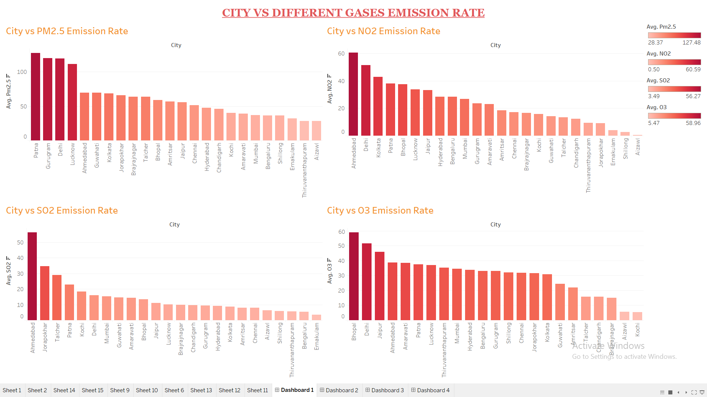

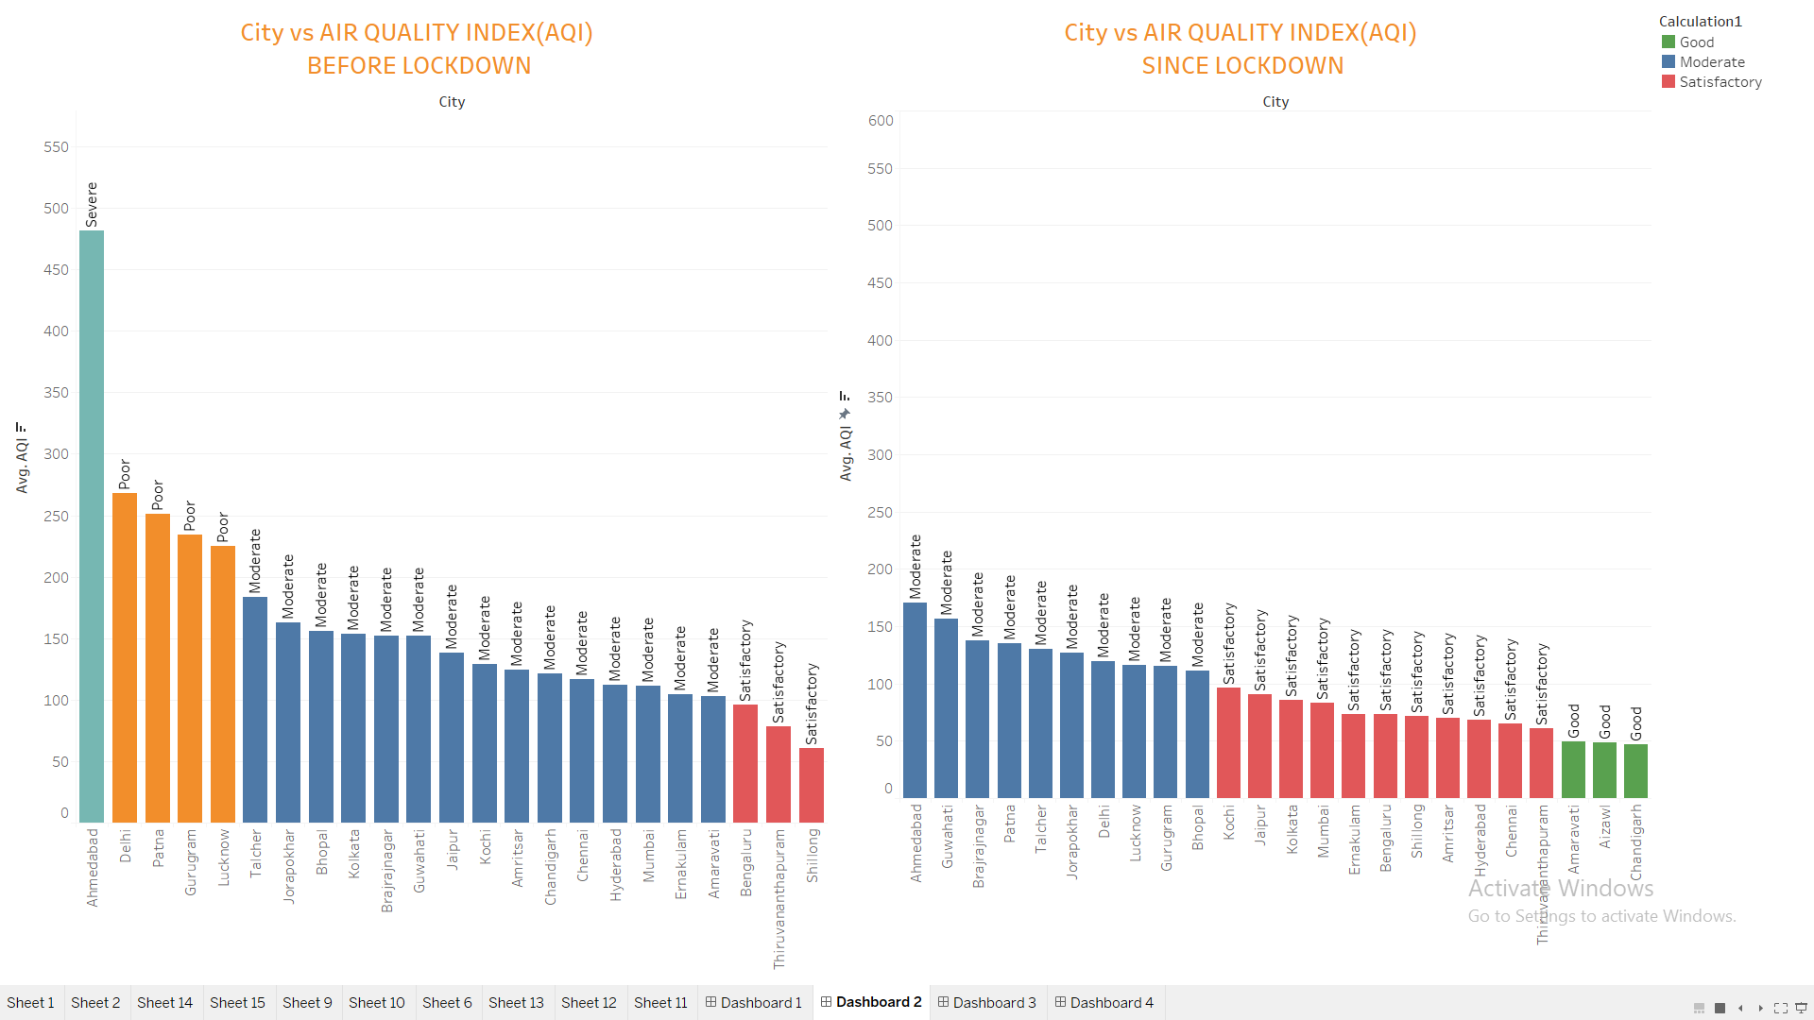

**Conclusion and Prediction :**

Thus after lockdown the pollution level have drastically reduced and the Air Quality is getting better and better.We can see from the above table that some of the cities have even got the good air quality from poor and some have got to moderate from severe level of pollution.Also the predictions for the years from 2020-2022 are showing an increase in pollution as after lockdown people wont tend to use the government transport immediately.Also all industries starting at once would impact the current air quality.By 2022 the air quality is expected to get poor again.

**Comparison of concentration of gases and AQI before and after lockdown**

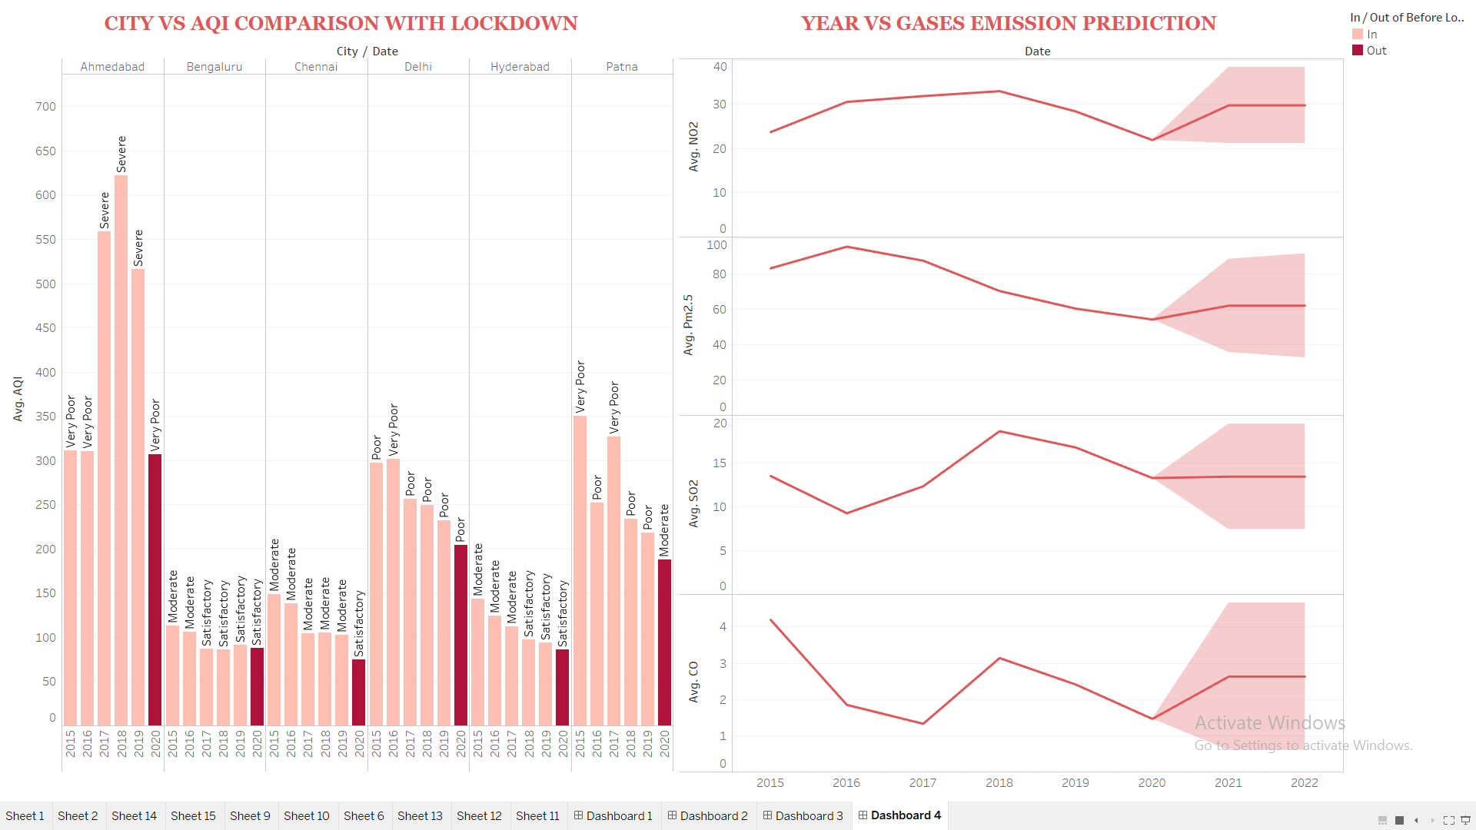

|  |  |  |
| --- | --- | --- |
| **CITY** | **AQI BEFORE LOCKDOWN** | **AQI AFTER LOCKDOWN** |
| DELHI | Poor | Moderate |
| LUCKNOW | Poor | Moderate |
| PATNA | Poor | Moderate |
| AHMEDABAD | Severe | Moderate |
| BHOPAL | Moderate | Satisfactory |
| CHANDIGARH | Moderate | Good |

**PREDICTION FOR THE QUALITY OF AIR FOR INDIA AND SOME OF THE CITIES**

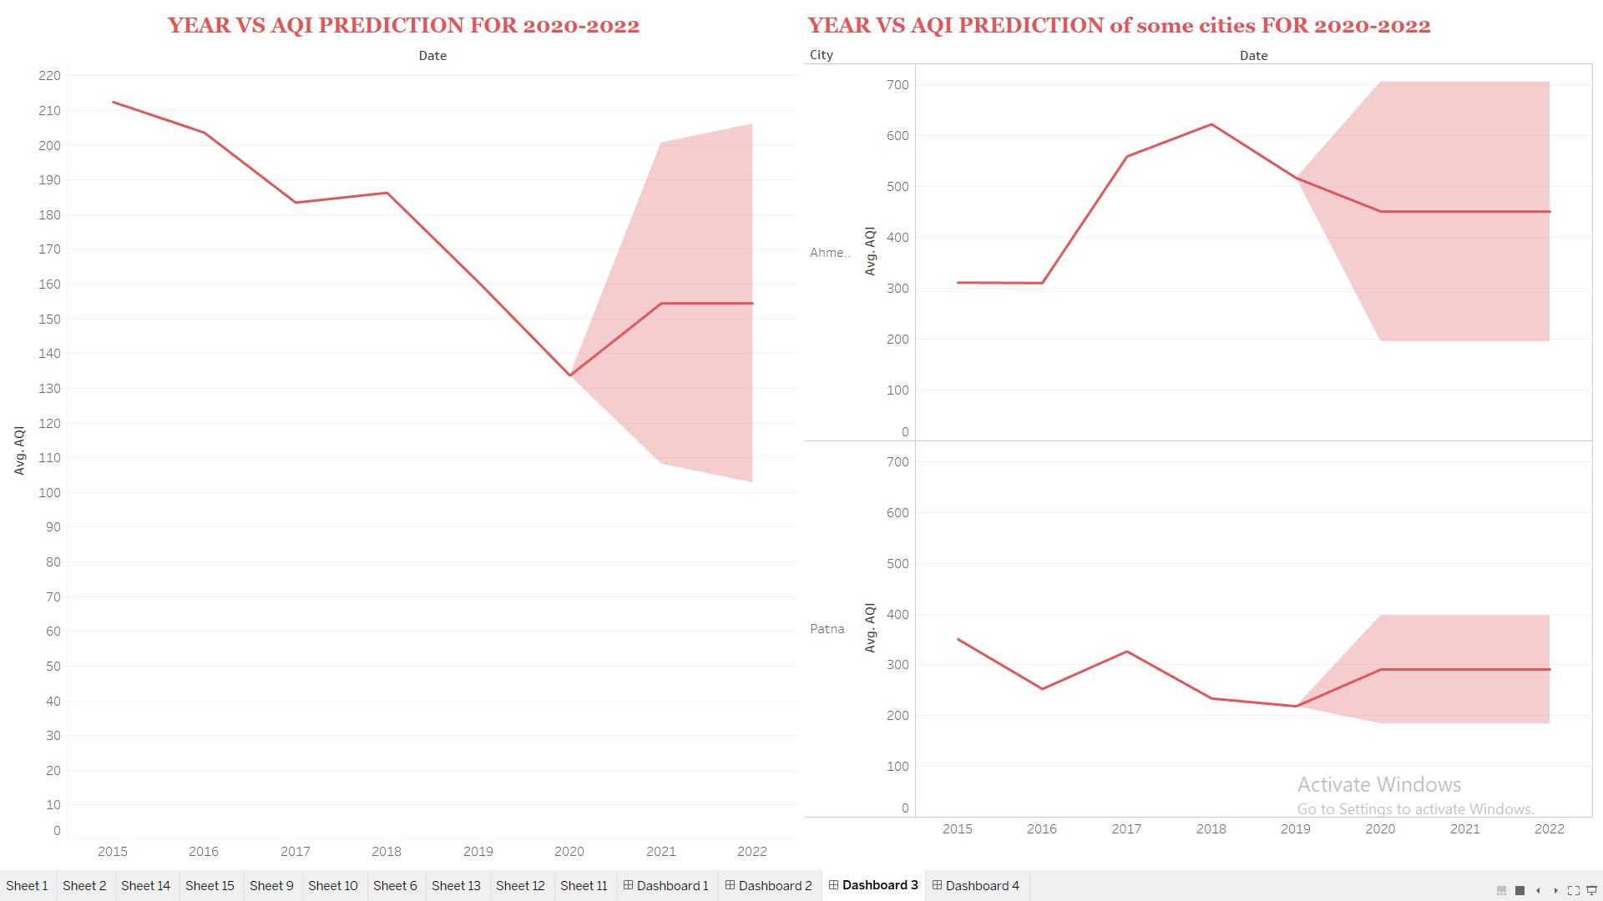

Thus the above graphs show that the air quality india has experienced in lockdown is the best since 2015.Also this air quality is further expected to be getting bad as industries start and lockdown ends leading to lots of vehicles on roads and lots of industries getting opened at the same time.Also predictions show significant rise in pollution levels after 2021.